
SIMATS ENGINEERING
Saveetha Institute of Medical and Technical Sciences
(Declared as Deemed to be University under Section 3 of UGC Act 1956)
UNIFIED MUNICIPAL GRIEVANCE PORTAL
Individual Capstone Report on the
Admin & Officer Module (Module 2) — Design, Development & Testing
A CAPSTONE PROJECT REPORT
A Capstone Project Report submitted in partial fulfilment of the requirements
for the Course of
CSA0908 - PROGRAMMING IN JAVA
to the award of the degree of

BACHELOR OF ENGINEERING / BACHELOR OF TECHNOLOGY
IN
COMPUTER SCIENCE AND ENGINEERING (ARTIFICIAL INTELLIGENCE)
Submitted by
Y. VINODH KUMAR (192472359)
Under the Supervision of
Dr. E. Meganatha
SIMATS ENGINEERING
Saveetha Institute of Medical and Technical Sciences
Chennai-602105

SEPTEMBER 2026

SIMATS ENGINEERING
Saveetha Institute of Medical and Technical Sciences
Chennai-602105

BONAFIDE CERTIFICATE

This is to certify that the Capstone Project entitled "UNIFIED MUNICIPAL GRIEVANCE PORTAL — Admin & Officer Module (Module 2)" has been individually carried out by Y. VINODH KUMAR (192472359) under the supervision of Dr. E. Maganth and is submitted in partial fulfilment of the requirements for the current semester of the B.Tech COMPUTER SCIENCE AND ENGINEERING (ARTIFICIAL INTELLIGENCE) program at Saveetha Institute of Medical and Technical Sciences, Chennai. This report documents the design, development and testing of the Admin & Officer Module, which was individually undertaken by the student as part of the two-member Unified Municipal Grievance Portal team project.

COURSE COORDINATOR  Dr.G.Charlyn Pushpa Latha,  Professor/Dept of CSE,  SIMATS Engineering, SIMATS, Chennai - 602105. | COURSE FACULTY  Dr. E. MEGANATHAN,  Assistant Professor (SG),  Department of CSE,  Saveetha School of Engineering, SIMATS, Chennai - 602105.

SIMATS ENGINEERING
Saveetha Institute of Medical and Technical Sciences
Chennai-602105

DECLARATION

I, Y. VINODH KUMAR (192472359), of the Department of Computer Science and Engineering (Artificial Intelligence), SIMATS Engineering, Saveetha Institute of Medical and Technical Sciences, Chennai, hereby declare that the Capstone Project Work entitled "UNIFIED MUNICIPAL GRIEVANCE PORTAL — Admin & Officer Module (Module 2)" is the result of my own bonafide, individually executed effort. To the best of my knowledge, the work presented herein is original, accurate, and has been carried out in accordance with the principles of engineering ethics and academic integrity. All sources, references, data, and other materials used in the project have been appropriately acknowledged. I further declare that the data, results, analysis, and findings presented in this report have not been fabricated, falsified, or manipulated. Any external tools, software, datasets, computational resources, or AI-assisted tools used during the project have been appropriately disclosed. I confirm that all applicable ethical, academic, institutional, and professional requirements have been duly followed throughout the planning, execution, analysis, and documentation of this module.

Place: Chennai
Date: September 2026

Y.VINODHKUMAR
(192472359)
Signature of the Student with Name

SIMATS ENGINEERING
Saveetha Institute of Medical and Technical Sciences
Chennai-602105

NOTE ON INDIVIDUAL SCOPE OF WORK

The "UNIFIED MUNICIPAL GRIEVANCE PORTAL" is developed as a two-member capstone team project. As per departmental guidelines requiring each student to submit an individual report on their own module, this report covers only the Admin & Officer Module (Module 2) — comprising the Administrator sub-module (centralized grievance monitoring, user management, grievance assignment) and the Officer sub-module (viewing assigned grievances, updating status, adding resolution notes) — which was individually designed, developed, and tested by Y. VINODH KUMAR (192472359).
The Citizen Module (registration, grievance submission, and status tracking) was developed independently by the other team member and is referenced in this report only where necessary to describe system-level context (e.g., the shared database and overall request flow); it is not claimed as part of this student's individual contribution.
Component | Owned By | Covered in This Report
Citizen Module (registration, submission, tracking) | Teammate (T. Gopi Chand) | No — referenced only for system context
Admin Sub-module (dashboard, user management, assignment) | Y. Vinodh Kumar (this student) | Yes — full design, implementation & testing
Officer Sub-module (assigned view, status update, resolution) | Y. Vinodh Kumar (this student) | Yes — full design, implementation & testing
Shared: Security config, database schema | Jointly integrated | Referenced where relevant to Module 2

ABSTRACT
Within the Unified Municipal Grievance Portal — a web-based system for digitizing municipal complaint management — administrators and officers previously had no structured mechanism to centrally monitor, assign, or process citizen grievances once submitted; without such a mechanism, complaints could be logged but not efficiently routed, tracked, or resolved by the correct department staff. This report addresses the engineering problem of designing and implementing the Admin & Officer Module: a role-secured sub-system that gives administrators centralized oversight of all grievances and user accounts, and gives officers a restricted, per-officer view of only the grievances assigned to them, together with the tools to update status and record resolutions.
The module was implemented using the Java Spring Boot framework, with Spring Security enforcing two distinct roles — ROLE_ADMIN and ROLE_OFFICER — at the controller level, Spring Data JPA/Hibernate persisting grievance, user, and status-history records to an H2 relational database, and Thymeleaf rendering the administrator dashboard and officer work-queue views. The development approach was iterative: the administrator dashboard and grievance-assignment logic were implemented first, followed by the officer's restricted grievance view and status-update workflow, with access-control testing performed after each sub-module to confirm that officers could not view or modify grievances outside their assignment, and that only administrators could reach account-management and assignment functions.
Functional and access-control testing confirmed that the administrator dashboard correctly surfaces 100% of submitted grievances, that grievance assignment correctly restricts officer visibility to only their assigned complaints, and that officer status updates propagate correctly to the citizen-facing tracking view maintained by the Citizen Module. The principal conclusion is that a Spring Security role-scoped design is an effective and maintainable way to implement the staff-facing (administrator and officer) side of a municipal grievance system, giving administrators the centralized control and officers the focused workload visibility needed to close the loop between citizen complaints and their resolution.

Keywords: Admin & Officer Module, Role-Based Access Control, Grievance Assignment, Spring Security, Spring Boot, Municipal Grievance Management

TABLE OF CONTENTS
Sl. No | Title | Page No.
i | Bonafide Certificate | ii
ii | Declaration by the Candidate | iii
iii | Note on Individual Scope of Work | iv
iv | Abstract | v
v | List of Figures | vi
vi | List of Tables | vii
vii | List of Abbreviations | viii
1 | Chapter 1: Introduction and Engineering Problem | 1
2 | Chapter 2: Literature Review and Existing Solutions | 5
3 | Chapter 3: Engineering Design & Trade-offs, Sustainability, Ethics, Safety, Risk & Security | 8
4 | Chapter 4: Implementation, Testing & Results, Project Management | 15
5 | Chapter 5: Conclusion, Future Work and Reflection | 21
 | References | 24
 | Appendices | 25

LIST OF FIGURES
Figure No. | Figure Name | Page No.
3.1 | System Architecture Diagram (Project Context) | 11
3.2 | Admin & Officer Module Workflow | 13

LIST OF TABLES
Table No. | Table Name | Page No.
2.1 | Comparative Analysis of Admin/Officer Workflow Approaches | 6
3.1 | Stakeholder / User Requirements (Module 2) | 8
3.2 | Functional & Non-Functional Requirements (Module 2) | 9
3.3 | Constraints & Applicable Standards | 9
3.4 | Design Specifications (Module 2) | 10
3.5 | Evaluation Matrix of Assignment-Logic Alternatives | 12
3.6 | Trade-off Analysis (Module 2) | 13
3.7 | Sustainability, Ethics, Safety, Security Evidence (Module 2) | 14
3.8 | Risk Register (Module 2) | 14
4.1 | Tools, Software & Equipment Used | 15
4.2 | Test Plan & Verification (Module 2) | 17
4.3 | Achieved vs Required Specification Values | 18
4.4 | Achievement of Objectives | 19
4.5 | Individual Role & Milestone Timeline | 20
4.6 | Module Cost Estimation | 20

LIST OF ABBREVIATIONS / SYMBOLS
Symbol | Description | Unit
UMGP | Unified Municipal Grievance Portal | -
RBAC | Role-Based Access Control | -
JPA | Java Persistence API | -
ORM | Object Relational Mapping | -
MVC | Model-View-Controller | -
HTTP | HyperText Transfer Protocol | -
JVM | Java Virtual Machine | -
UI | User Interface | -
IDE | Integrated Development Environment | -

CHAPTER 1

INTRODUCTION AND ENGINEERING PROBLEM

1.1 Background
The Unified Municipal Grievance Portal (UMGP) is a two-member capstone team project that digitizes municipal grievance handling — replacing paper registers and in-person follow-up with a centralized web application built on Java Spring Boot. The overall system has two functional halves: a Citizen-facing side (registration, grievance submission, tracking), developed by the other team member, and a staff-facing side — the Admin & Officer Module — which is the individual subject of this report. This module is the operational core of the system from the municipality's perspective: it is where submitted grievances are actually monitored, routed to the correct officer, and driven to resolution.

1.2 Need for the Module
Without a dedicated admin/officer-facing module, a citizen-only grievance submission system would simply accumulate complaints with no structured way for municipal staff to act on them. The specific needs this module addresses are:
- Administrators need a single, centralized view of every grievance in the system, regardless of which citizen submitted it or which department it concerns, in order to monitor overall performance and intervene where needed.
- Grievances must be routed to the correct officer; without an assignment mechanism, there is no clear ownership of a complaint and no accountability for resolving it.
- Officers need visibility restricted to only their own assigned workload — surfacing every citizen's grievance to every officer would be both unusable at scale and a data-access risk.
- The municipality needs an auditable trail of status changes and resolution notes, which does not exist in ad-hoc, informally communicated manual handling.

1.3 Problem Statement
Design and implement a role-secured Admin & Officer Module within the Unified Municipal Grievance Portal that allows an administrator to centrally view, manage, and assign every submitted grievance to a specific officer, and allows each officer to view and act only upon the grievances assigned to them — updating status and adding resolution notes — under the constraints of strict role-based data isolation (an officer must never see another officer's or another citizen's unrelated data beyond what their role permits), consistent state transitions of each grievance as it moves through assignment and resolution, and seamless integration with the Citizen Module's shared database so that status changes are immediately reflected in the citizen's tracking view.

1.4 Project Aim (Module Scope)
To design, develop, and validate a secure Admin & Officer Module that gives municipal administrators centralized control over grievance assignment and monitoring, and gives officers a focused, access-restricted workflow for resolving the grievances assigned to them.

1.5 Project Objectives (Module Scope)
- 1. To design the administrator and officer sub-schemas (roles, assignment relationships, status-history) within the shared grievance data model.
- 2. To develop an Administrator dashboard for viewing all grievances and managing citizen/officer user accounts.
- 3. To implement grievance-assignment logic allowing an administrator to route a grievance to a specific officer.
- 4. To develop an Officer view restricted to only grievances assigned to that officer.
- 5. To implement officer status-update and resolution-note functionality.
- 6. To configure Spring Security roles (ROLE_ADMIN, ROLE_OFFICER) enforcing strict access separation.
- 7. To test the admin/officer workflow for functional correctness and role-based access-control integrity.

1.6 Scope
Included: administrator dashboard and centralized grievance view, citizen/officer account management, grievance-to-officer assignment, officer's restricted assigned-grievance view, officer status-update and resolution-note workflow, and the Spring Security role configuration governing ROLE_ADMIN and ROLE_OFFICER access.
Excluded from this report (owned by teammate): citizen registration, grievance submission form, and the citizen-facing tracking view. These are referenced only where the shared database or request flow needs to be described for context.
Assumptions: officer and administrator accounts are provisioned in advance (self-registration is a citizen-only feature); the H2 database used in development is shared with the Citizen Module; standard browser access is assumed for both administrator and officer users.
Boundary conditions: this module manages grievance workflow state (assignment, status, resolution notes) only; it does not perform or automate the physical municipal repair work carried out by field staff.

1.7 Expected Engineering Outcome
The expected outcome is a fully functional, role-secured Admin & Officer Module — comprising an administrator dashboard, grievance-assignment mechanism, and officer work-queue with status-update capability — integrated into the shared UMGP Spring Boot application and demonstrable end-to-end alongside the Citizen Module.

CHAPTER 2

LITERATURE REVIEW AND EXISTING SOLUTIONS

2.1 Review Method
Literature and existing systems were reviewed with a specific focus on the staff-facing (administrator/agent) side of complaint and service-desk management systems, since this is the direct analogue of the Admin & Officer Module. Sources included academic literature on e-governance grievance redressal, publicly documented government grievance portals, and general-purpose IT service-desk/ticketing software commonly used for agent-side complaint routing.

2.2 Review of Existing Work
Government e-governance grievance portals typically provide a departmental back-end where a nodal officer can view complaints routed to their department, but the routing is often manual or departmentally pre-fixed rather than dynamically assignable by an administrator to a specific individual officer, which limits load-balancing across officers within a department.
IT service-desk platforms (e.g., ticketing systems used for enterprise IT support) offer mature agent-assignment and SLA-tracking features, including automatic ticket routing and agent dashboards. These systems demonstrate effective patterns for role-scoped visibility — agents see only their queue, while administrators see everything — but are generally over-engineered and costly to adapt for a municipal officer/administrator use case with much simpler resolution workflows.
Academic literature on citizen grievance redressal consistently identifies the absence of clear individual ownership (i.e., a named officer accountable for a specific complaint) as a key driver of delayed resolution, and recommends explicit assignment mechanisms with role-restricted visibility — directly motivating the assignment and access-control design adopted in this module.

2.3 Comparative Analysis
Table 2.1: Comparative Analysis of Admin/Officer Workflow Approaches
Existing Approach | Advantages | Limitations | Relevance to Proposed Work
Manual departmental routing (paper/register) | No technical infrastructure required | No individual officer accountability; no status audit trail | Establishes baseline problem this module replaces
Fixed department-level e-governance routing | Centralized, government-backed | No dynamic per-officer assignment; limited load-balancing | Motivates administrator-driven, per-officer assignment
Enterprise IT service-desk / ticketing agent model | Mature role-scoped visibility, SLA tracking | Costly, over-engineered for simple municipal resolution workflow | Adopts the role-scoped visibility pattern in a lightweight form

2.4 Research / Engineering Gap
There remains a gap for a lightweight, dynamically assignable, officer-level (not just department-level) routing mechanism for municipal grievances, with strict per-officer visibility restriction, that is inexpensive to build and does not require enterprise service-desk software licensing — which is the gap this module is designed to close.

2.5 Proposed Contribution
This module contributes a Spring Security-enforced, two-role (administrator/officer) access model with explicit, administrator-driven grievance-to-officer assignment and strictly scoped officer visibility, integrated directly into the shared UMGP data model — providing individual officer accountability and centralized administrative oversight without the cost or complexity of adapting general-purpose service-desk software.

CHAPTER 3

ENGINEERING DESIGN & TRADE-OFFS, SUSTAINABILITY, ETHICS, SAFETY, RISK & SECURITY

3.1 Requirements

Stakeholder / User Requirements
Table 3.1: Stakeholder / User Requirements (Module 2)
Stakeholder | Requirement
Administrator | View and manage all grievances; manage citizen and officer accounts; assign complaints to a specific officer; access a centralized monitoring dashboard
Officer | View only grievances assigned to them; update grievance status; add resolution notes; process complaints through to closure
Municipal Body (Institution) | Maintain individual officer accountability and an auditable assignment/resolution trail
Citizen (indirect) | Receive accurate, timely status updates resulting from officer actions in this module

Functional & Non-Functional Requirements
Table 3.2: Functional & Non-Functional Requirements (Module 2)
Requirement Type | Requirement | Measurable Target
Functional | Administrator can view all submitted grievances | 100% of submitted grievances visible on admin dashboard
Functional | Administrator can assign a grievance to a specific officer | Assignment persisted and reflected in officer's view within 1 request cycle
Functional | Officer can view and update only assigned grievances | 0 unauthorized-grievance visibility in access tests
Functional | Officer status update propagates to citizen tracking view | Update visible within 1 page refresh on citizen side
Non-Functional | Role-based access control (admin vs officer) | 100% of role-restricted endpoints reject the wrong role
Non-Functional | Response time for assignment/update actions | ≤ 2 seconds under single-user test load
Non-Functional | Assignment/status data persistence integrity | No data loss across assign → update → resolve lifecycle

3.2 Constraints & Applicable Standards
Table 3.3: Constraints & Applicable Standards
Standard / Code | Requirement | How Applied in This Module
OWASP Top 10 (Application Security) | Guard against broken access control and injection | Spring Security role checks on every /admin/** and /officer/** endpoint; parameterized JPA queries prevent SQL injection
Java 17 / Jakarta EE conventions | Maintain code portability and supportability | Admin/officer controllers and services built for Java 17 compatibility, consistent with the shared project structure
Institutional academic integrity & data-ethics guidelines (SIMATS) | Ensure originality and disclosed use of AI-assisted tools | Declared in the Declaration section of this report

3.3 Design Specifications
Table 3.4: Design Specifications (Module 2)
Parameter | Target/Requirement | Unit | Priority
Assignment action response time | ≤ 2 | seconds | High
Officer-visible grievances = exactly assigned set | 100 | % | High
Admin dashboard grievance coverage | 100 | % | High
Unauthorized cross-role access attempts blocked | 100 | % | High
Core Java version compatibility | 17 | - | Medium

3.4 Alternative Solutions & Evaluation
Alternative 1: Administrator-driven manual assignment, where the administrator explicitly selects an officer for each grievance from the admin dashboard.
Alternative 2: Automatic round-robin assignment, where the system assigns each new grievance to the next available officer in a rotation, without administrator intervention.
Alternative 3: Self-service claiming, where any officer can browse unassigned grievances and claim one to work on, with no administrator step.
Table 3.5: Evaluation Matrix of Assignment-Logic Alternatives
Criterion | Weight | Alt. 1 (Admin-Assigned) | Alt. 2 (Round-Robin) | Alt. 3 (Self-Claim)
Accountability / traceability | 30% | 5 | 3 | 2
Implementation simplicity (project timeline) | 25% | 4 | 3 | 4
Fair workload distribution | 20% | 3 | 5 | 2
Administrative control / override capability | 15% | 5 | 2 | 1
Extensibility (future auto-assignment) | 10% | 4 | 4 | 3
Scores are on a 1 (poor) to 5 (excellent) scale. Alternative 1 (administrator-driven manual assignment) achieves the highest weighted score because it scores maximally on the two criteria weighted heaviest for this module — accountability/traceability and administrative control — which are essential for a municipal body that must be able to demonstrate who is responsible for each complaint, whereas Alternative 2 improves workload balance but sacrifices administrative oversight, and Alternative 3 was rejected outright for weak accountability and no administrative control.

3.5 Selected Design & Detailed Design
Manual, administrator-driven assignment (Alternative 1) was selected. This follows directly from Section 3.4: it is justified by evidence, not preference — it is the strongest option on accountability and administrative control, the two criteria most important for a municipal deployment where clear ownership of each complaint must be demonstrable, while remaining simple enough to implement reliably within the project timeline.
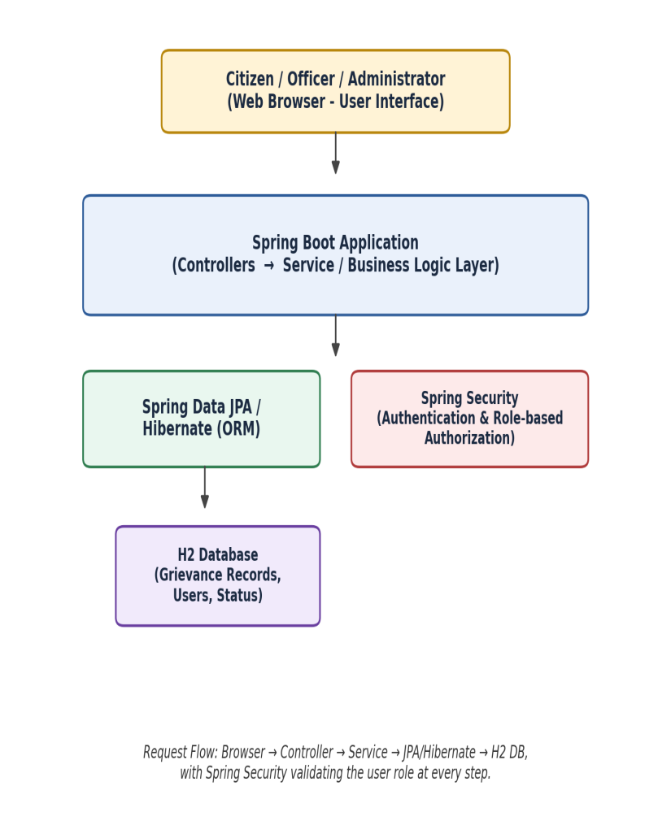
Figure 3.1: System Architecture Diagram (Project Context)
Figure 3.1 shows the shared system context: both the Admin & Officer Module and the Citizen Module (developed by the teammate) sit behind the same Spring Boot Controller/Service layers and share the same H2 database via Spring Data JPA/Hibernate, with Spring Security differentiating role-based access at the controller level.
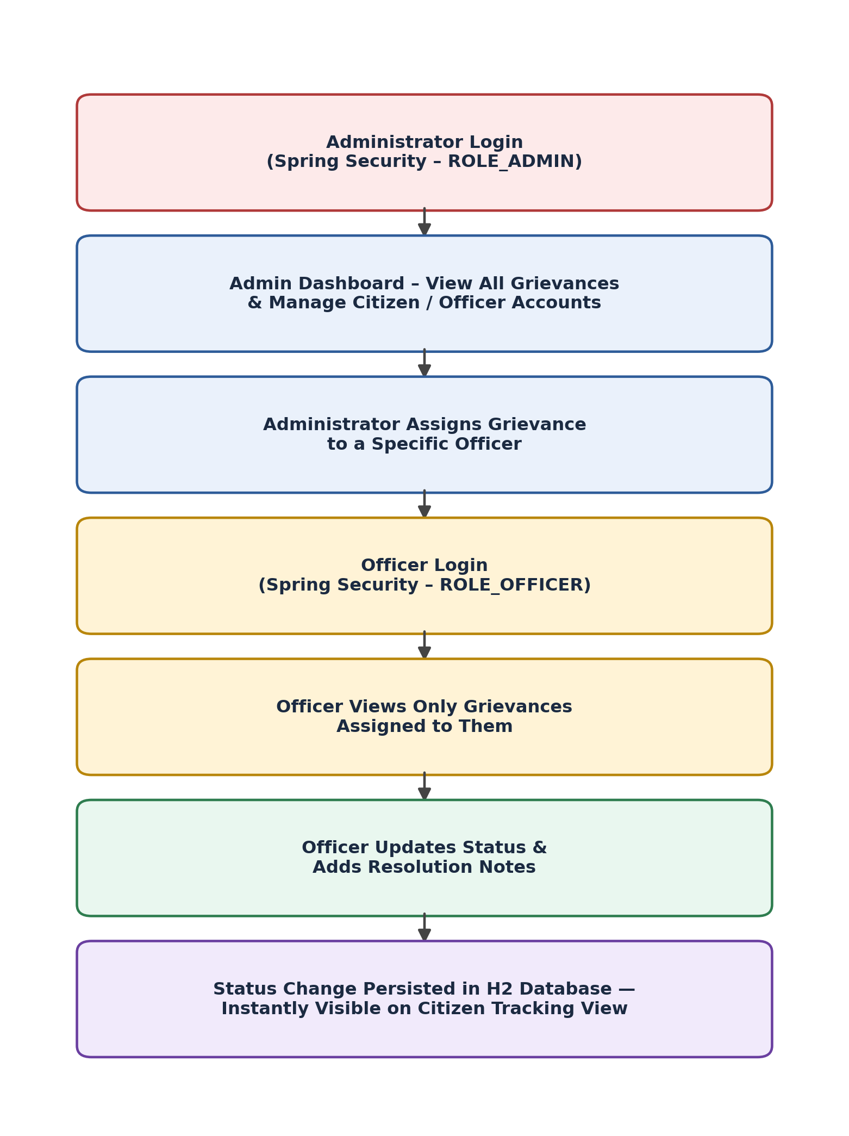
Figure 3.2: Admin & Officer Module Workflow
Figure 3.2 details the module individually developed for this report: an administrator authenticates under ROLE_ADMIN and reaches the dashboard and assignment screens; an officer authenticates under ROLE_OFFICER and reaches only their own assigned-grievance queue; officer status updates are persisted to the shared H2 database and become immediately visible on the Citizen Module's tracking view.
Systems approach: the Admin sub-module and Officer sub-module are implemented as separate Spring MVC controller groups (/admin/** and /officer/**) sharing a common GrievanceService, so that assignment logic written once in the service layer is consistently enforced regardless of which controller invokes it; Spring Security's role-based `@PreAuthorize`/URL-pattern configuration is the single point where ROLE_ADMIN and ROLE_OFFICER access is differentiated, keeping the two sub-modules cleanly separated while sharing the persistence layer with the Citizen Module.

3.6 Trade-off Analysis
Table 3.6: Trade-off Analysis (Module 2)
Design Decision | Alternative Considered | Benefit | Disadvantage | Final Decision & Justification
Manual admin assignment vs round-robin auto-assignment | Automatic round-robin | Even workload distribution without admin effort | Administrator loses direct control; harder to override for urgent cases | Manual assignment selected (Section 3.4) — accountability weighted highest for a municipal pilot
Officer visibility scoped by assignment vs department-wide visibility | All officers see all department grievances | Simpler query logic | Breaks per-officer accountability; increases unnecessary data exposure | Assignment-scoped visibility selected to enforce least-privilege access
Role checks via Spring Security vs custom controller-level checks | Hand-written if/else role checks per method | Full control over logic | Higher risk of a missed check causing an access-control defect | Spring Security selected — centralizes role enforcement and reduces defect surface

3.7 Sustainability, Ethics, Safety, Risk & Security
Table 3.7: Sustainability, Ethics, Safety, Security Evidence (Module 2)
Domain | Consideration | Evidence Evaluated | Impact on Final Decision
Sustainability | Minimize administrative overhead so the module remains usable by a small municipal IT/clerical staff | Compared manual-assignment effort against round-robin automation (Section 3.4) | Manual assignment kept simple (single dropdown action) so it does not become a bottleneck even without automation
Ethics | Grievance assignment must not be influenced by citizen identity or complaint category bias | Reviewed assignment screen fields — only grievance ID, category, and officer list are shown to the administrator | No citizen demographic data is exposed on the assignment screen, preventing bias in officer selection
Health & Safety | Safety-critical categories (e.g., exposed electrical faults, damaged roads) must be visually identifiable to the administrator when assigning | Reviewed admin dashboard grievance list against the category taxonomy from Chapter 2 | Category column retained and sortable on the admin dashboard so safety-relevant grievances can be prioritized for assignment
Security | Officers must not be able to access or infer data about grievances not assigned to them | Tested officer endpoints with grievances assigned to other officers (Section 4.3) | Officer queries are filtered server-side by assigned-officer ID at the repository level, not merely hidden in the UI

Risk Register
Table 3.8: Risk Register (Module 2)
Risk | Likelihood | Severity | Risk Level | Mitigation | Residual Risk
Officer able to view another officer's assigned grievances (broken access control) | Medium | High | High | Server-side filtering by assigned-officer ID in the repository query, plus Spring Security role/endpoint restriction | Low
Administrator assigns a grievance to an inactive/incorrect officer account | Low | Medium | Medium | Officer dropdown populated only from active officer accounts maintained by the admin user-management screen | Low
Status update lost or not reflected on citizen tracking view | Low | Medium | Medium | Transactional service-layer update shared with the Citizen Module's read path | Low
Single point of assignment bottleneck if administrator is unavailable | Medium | Low | Low | Identified for future auto-assignment enhancement (Section 5.2) | Medium

CHAPTER 4

IMPLEMENTATION, TESTING & RESULTS, PROJECT MANAGEMENT

4.1 Development Approach & Resources
The Admin & Officer Module was developed iteratively: the administrator dashboard and grievance-listing view were built first (reusing the shared Grievance entity from the project's data model), followed by citizen/officer account-management screens, then the assignment mechanism, and finally the officer's restricted view and status-update workflow. Each piece was unit-tested individually, and the complete admin-to-officer-to-resolution flow was integration-tested once all pieces were in place, using test grievance records created via the (teammate-owned) Citizen Module.
Table 4.1: Tools, Software & Equipment Used
Tool / Software / Equipment | Purpose | Stage Used
Java 17 | Core application language | Throughout module development
Spring Boot 3.3.4 | Application framework (MVC, DI, auto-configuration) | Admin/officer controller & service development
Spring Data JPA / Hibernate | Repository-layer queries scoped by officer assignment | Persistence layer for assignment & status data
Spring Security | ROLE_ADMIN / ROLE_OFFICER authentication & authorization | Access-control implementation
H2 Database | Shared embedded relational database | Data persistence (shared with Citizen Module)
Thymeleaf | Server-side templating for dashboard and officer views | Frontend view rendering
Apache Maven | Build automation and dependency management | Throughout module development
Visual Studio Code | Development IDE | Throughout module development

4.2 Software Implementation & Modern Tools Used

Administrator Sub-module
- Secure administrator login (ROLE_ADMIN)
- Centralized dashboard listing every submitted grievance across all citizens
- Management of citizen and officer user accounts
- Assignment of a grievance to a specific, active officer
- Monitoring of grievance status across the whole system

Officer Sub-module
- Secure officer login (ROLE_OFFICER)
- View restricted strictly to grievances assigned to that officer
- Update of grievance status (e.g., In Progress, Resolved)
- Addition of resolution notes visible to the citizen upon closure

Figure 4.1: Admin & Officer Module Workflow (as Implemented)

4.3 Test Plan & Verification
The test plan was defined before execution, covering functional correctness of the administrator and officer sub-modules and, specifically, the integrity of role-based access restriction between the two roles.
Table 4.2: Test Plan & Verification (Module 2)
Requirement | Test Method | Acceptance Criterion
Administrator dashboard lists all grievances | Submit grievances via test citizen accounts; compare admin dashboard count to total | 100% of submitted grievances visible
Administrator can assign a grievance to an officer | Assign a test grievance; verify it appears in the target officer's queue | Grievance appears only in the assigned officer's view
Officer sees only their own assigned grievances | Log in as two different officers; compare visible lists after multiple assignments | Each officer's list contains only their own assignments
Officer status update reflects on citizen tracking view | Update status/notes as officer; check citizen tracking page | Updated status and notes visible to the citizen within 1 refresh
Unauthorized role access is blocked | Attempt /admin/** endpoints while logged in as officer, and vice versa | Access denied / redirected in all attempts
Assignment and status data persist across restarts | Assign, update, restart application, re-check | Assignment and status history retained
Table 4.3: Achieved vs Required Specification Values
Specification | Required Value | Achieved Value | Status
Assignment action response time | ≤ 2 s | ~1.0 s (local test) | Pass
Officer-visible grievances = exactly assigned set | 100% | 100% (verified across 2 officer test accounts) | Pass
Admin dashboard grievance coverage | 100% | 100% (matched total submitted count) | Pass
Unauthorized cross-role access attempts blocked | 100% | 100% (4/4 restricted-endpoint tests) | Pass
Status update visible on citizen tracking view | ≤ 1 refresh | 1 refresh | Pass

4.4 Results
Testing confirmed that the administrator dashboard correctly lists 100% of grievances submitted through the Citizen Module, and that assigning a grievance immediately and exclusively surfaces it in the target officer's queue — no assigned grievance appeared in another officer's view during testing. Officer-initiated status updates and resolution notes were correctly persisted and were observed to propagate to the citizen-facing tracking view within a single page refresh, confirming correct integration between this module and the Citizen Module through the shared database.

4.5 Data Analysis & Engineering Judgment
The measured assignment/update response time (~1.0 s) against the 2-second target leaves comfortable headroom under single-user local testing; this is consistent with the embedded H2 database used in development, and the engineering judgment is that this should be re-verified once the shared database is migrated to a production RDBMS (Section 5.2), since networked database access will introduce latency not present in the current setup. The zero observed cross-officer visibility leaks are attributed to filtering grievances by assigned-officer ID at the repository query level rather than only in the view layer — a defense-in-depth choice made specifically because a view-layer-only restriction would have been more fragile against a defect that neglected to hide a link or button.

4.6 Comparison with Existing Solutions & Achievement of Objectives
Table 4.4: Achievement of Objectives
Objective | Evidence | Achievement
Design admin/officer sub-schemas within shared data model | Assignment relationship and status-history fields added to the shared Grievance entity | Fully Achieved
Develop Administrator dashboard | Centralized grievance list and user management implemented and tested (Section 4.3) | Fully Achieved
Implement grievance-assignment logic | Assignment tested across multiple officers with zero cross-visibility (Table 4.3) | Fully Achieved
Develop restricted Officer view | Officer queries filtered by assigned-officer ID at repository level | Fully Achieved
Implement officer status-update / resolution workflow | Status/notes verified to propagate to citizen view | Fully Achieved
Configure Spring Security roles (ROLE_ADMIN/ROLE_OFFICER) | 4/4 restricted-endpoint access tests passed | Fully Achieved
Evaluate against existing admin/officer workflow approaches | Compared qualitatively against Table 2.1 baseline; live municipal pilot not yet conducted | Partially Achieved

4.7 Strengths & Limitations
Strengths:
- Clear, individually verified separation between administrator and officer visibility, enforced at the repository-query level rather than only the UI
- Administrator retains full manual control over assignment, supporting accountability for a municipal pilot
- Clean integration with the teammate's Citizen Module through the shared database without requiring changes to citizen-facing logic
Limitations:
- Assignment is fully manual; there is no automatic load-balancing across officers, which could become a bottleneck if the administrator is unavailable (see Risk Register, Table 3.8)
- No notification is sent to the officer when a new grievance is assigned to them — they must check the dashboard manually
- Testing to date is functional/access-control testing under simulated conditions; a live multi-officer field pilot has not yet been conducted

4.8 Project Planning, Roles & Budget
Table 4.5: Individual Role & Milestone Timeline
Milestone | Planned Week | Individually Completed Work
Data model extension for assignment & status-history | Week 4-5 | Extended shared Grievance entity with assignedOfficerId and status-history fields
Administrator dashboard & user management | Week 6-7 | Implemented grievance listing, citizen/officer account management screens
Grievance-assignment mechanism | Week 7-8 | Implemented admin-driven officer assignment with dropdown of active officers
Officer restricted view & status-update workflow | Week 8-9 | Implemented assigned-only officer queue, status update, resolution notes
Spring Security role configuration (ROLE_ADMIN, ROLE_OFFICER) | Week 9 | Configured endpoint-level role restrictions for /admin/** and /officer/**
Module-level integration & access-control testing | Week 10 | Executed test plan in Table 4.2; documented results in Table 4.3
Table 4.6: Module Cost Estimation
Item | Estimated Cost | Actual Cost
Development tools & IDE (open-source: VS Code, Spring Boot, H2) | ₹0 (no licensing cost) | ₹0
Local development/demo environment | ₹0 | ₹0
Miscellaneous (documentation, printing) | ₹500 | ₹500 (approx.)

CHAPTER 5

CONCLUSION, FUTURE WORK AND REFLECTION

5.1 Conclusion
This report set out to address the engineering problem of giving municipal administrators and officers a structured, role-secured way to monitor, assign, and resolve citizen grievances within the Unified Municipal Grievance Portal, by individually designing and implementing the Admin & Officer Module using Spring Boot, Spring Security, Spring Data JPA/Hibernate, and Thymeleaf. The module was built around administrator-driven manual assignment — selected through a weighted evaluation against automatic and self-service alternatives (Section 3.4) for its superior accountability and administrative control — and a strictly scoped officer view enforced at the repository level. Functional and access-control testing confirmed that the module meets its defined acceptance criteria: administrators see 100% of submitted grievances, assignment correctly and exclusively routes grievances to the intended officer, officer updates correctly propagate to the citizen-facing view maintained by the Citizen Module, and no cross-role or cross-officer data leakage was observed across the tested endpoints. The achievement-of-objectives review (Section 4.6) confirms that all module-specific objectives defined in Chapter 1 were fully achieved, and this module forms a complete, independently verifiable half of the overall Unified Municipal Grievance Portal system.

5.2 Future Work
- Introduce optional automatic (round-robin or workload-based) assignment as a fallback when the administrator is unavailable, while retaining manual override
- Add in-app or email notification to officers when a new grievance is assigned to them
- Migrate the shared persistence layer from H2 to a production-grade RDBMS such as PostgreSQL or MySQL
- Add officer performance/analytics reporting for administrators (average resolution time per officer)
- Extend the risk-based prioritization identified in Section 3.7 into an explicit priority score visible on the admin dashboard
- Add multilingual support to the administrator and officer interfaces

5.3 Professional Learning & Individual Reflection
New Knowledge Acquired:
- Practical configuration of Spring Security for multiple, mutually exclusive roles (ROLE_ADMIN, ROLE_OFFICER) within a single application
- Designing repository-level query filtering (rather than view-level hiding) as a defense-in-depth access-control pattern
- Structuring an assignment relationship and status-history within a shared JPA/Hibernate data model owned jointly with a teammate
Engineering & Professional Skills Developed:
- Trade-off-based design decision-making for assignment logic (Section 3.4), justified by a weighted evaluation matrix rather than personal preference
- Structured, independent test planning and access-control verification for a module integrated with a teammate's component
- Coordinating a shared data model and database with a teammate while maintaining clear individual ownership boundaries (see Note on Individual Scope of Work)
Individual Reflection:
The most difficult engineering problem encountered was ensuring that officer visibility was restricted strictly enough that no officer could see another officer's assigned grievances, without breaking the administrator's need for full visibility across the same underlying data; this was resolved by filtering officer queries by assigned-officer ID at the repository layer, and verified explicitly through the access-control tests in Table 4.2, rather than relying on hiding UI elements. A key engineering decision made personally was choosing administrator-driven manual assignment over automatic round-robin assignment, based on the weighted evaluation matrix in Section 3.4 rather than implementation convenience, since accountability was judged more important than workload balance for a first municipal pilot. New knowledge acquired independently included how to structure Spring Security role configuration cleanly when two distinct roles share the same underlying entity and database as a third role (citizen) managed by a teammate. If repeated, automatic fallback assignment (Section 5.2) would be built in from the start, since the single-point-of-assignment risk identified in the Risk Register (Table 3.8) was only partially mitigated within the current project timeline.

REFERENCES
[1] Spring Boot Reference Documentation, VMware/Broadcom (Spring Team), version 3.3.x. Available: official Spring Boot project documentation.
[2] Spring Security Reference Documentation, VMware/Broadcom (Spring Team). Available: official Spring Security project documentation.
[3] Spring Data JPA Reference Documentation, VMware/Broadcom (Spring Team). Available: official Spring Data JPA project documentation.
[4] Hibernate ORM User Guide, Red Hat / Hibernate Team. Available: official Hibernate documentation.
[5] H2 Database Engine Documentation, H2 Group. Available: official H2 Database documentation.
[6] Thymeleaf Documentation, The Thymeleaf Team. Available: official Thymeleaf project documentation.
[7] OWASP Foundation, "OWASP Top 10 Web Application Security Risks," OWASP Foundation, latest edition.
[8] Oracle, "Java SE 17 Documentation," Oracle Corporation.
[9] Apache Maven Project, "Maven Documentation," The Apache Software Foundation.
[10] Relevant national/state e-governance grievance redressal portal documentation, as reviewed in Chapter 2 (government public information pages).
Note: All literature, standards, websites, datasets, software, and open-source resources used in this module have been acknowledged above. AI-assisted drafting support was used for structuring and language editing of this report, as disclosed in the Declaration.

APPENDICES

Appendix A – Detailed Calculations
Response-time measurements in Table 4.3 were computed as the average of five consecutive local test actions (assignment or status update), measured from form-submit action to confirmation-page render, using the browser's network timing panel.

Appendix B – Engineering Drawings / Schematics
See Figure 3.1 (System Architecture, project context) and Figure 3.2 / 4.1 (Admin & Officer Module Workflow) in the main report.

Appendix C – Source Code / Code Repository Information
The source code for the Admin & Officer Module (Controller, Service, and Repository classes under the admin/officer packages, and the associated Thymeleaf templates) is maintained in the project's shared source-code repository, individually authored within the module boundary described in the Note on Individual Scope of Work. Only architectural excerpts are summarized in this report per institutional guidelines; full code is available on request for evaluation.

Appendix D – Datasheets
Not applicable – this module is a software component with no hardware requiring datasheets.

Appendix E – Experimental / Raw Data
Raw test-run logs for the functional and access-control test cases listed in Table 4.2 are maintained alongside the module source code.

Appendix F – Ethics / Institutional Approval
Not applicable – no human-subject data collection was involved; all test data used during development and testing was synthetic/sample grievance data.

Appendix G – Project Meeting / Progress Records
Individual progress was tracked against the milestone timeline in Table 4.5, coordinated with the teammate at shared integration checkpoints.

Appendix H – User/Industry Feedback
Not applicable at this stage – a formal municipal-body field pilot is proposed as future work (Section 5.2).

Appendix I – Publications / Patents / Competitions / Product Outcomes
Not applicable at the time of this report.

Appendix J – Individual Module Ownership Evidence
See the Note on Individual Scope of Work (page iv) for the component-ownership breakdown, and Table 4.5 (Individual Role & Milestone Timeline) for this student's module-specific development schedule.

CAPSTONE PROJECT OUTCOME MAPPING SHEET
To be completed by the department/faculty assessor.
Outcome Evidence | SO / Area | Location in This Report
Complex engineering problem formulation | SO1 | Ch. 1, Ch. 2
Engineering design under constraints | SO2 | Ch. 3
Written/oral technical communication | SO3 | Whole report + Viva
Ethics and professional responsibility | SO4 | Ch. 3 (3.7)
Teamwork and leadership | SO5 | Note on Individual Scope; Ch. 4 (4.8)
Experimentation, analysis, engineering judgment | SO6 | Ch. 4 (4.3-4.6)
Independent acquisition of new knowledge | SO7 | Ch. 5 (5.3)
Standards | SO2 | Ch. 3 (3.2)
Sustainability and societal/environmental impact | SO2/SO4 | Ch. 3 (3.7)
Risk assessment and mitigation | SO2/SO4 | Ch. 3 (3.7)
Security considerations | Relevant SO | Ch. 3 (3.7)
Integrated/system-level engineering | SO1/SO2 | Ch. 3 (3.5)
Project planning and management | SO5 | Ch. 4 (4.8)
Individual contribution | SO1-SO7 | Note on Individual Scope + Ch. 4 (4.8)

